Open Compound Word

🔹 What is Open Compound Word
# Source: AI Source: Provided by: [Data Path: Persons Table -> ID Column: 1, Name_En Column: Motasem Essam] -> From: [Chatgpt (GPT-4-turbo)] on [7/25/2025]
An open compound word is a compound made up of two or more separate words that function as a single unit of meaning but are written with spaces — not joined or hyphenated.

✅ Definition:
# Source: AI Source: Provided by: [Data Path: Persons Table -> ID Column: 1, Name_En Column: Motasem Essam] -> From: [Chatgpt (GPT-4-turbo)] on [7/25/2025]
An open compound consists of two or more words written separately, but they work together to express one idea.

🔸 Examples of Open Compound Words:
# Source: AI Source: Provided by: [Data Path: Persons Table -> ID Column: 1, Name_En Column: Motasem Essam] -> From: [Chatgpt (GPT-4-turbo)] on [7/25/2025]
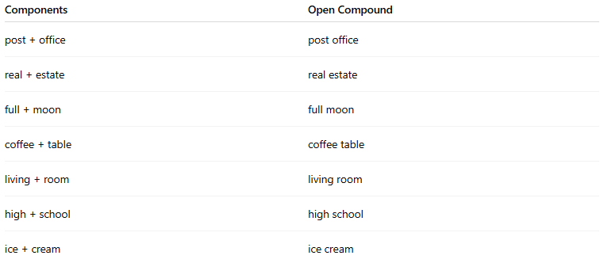
Components | Open Compound
post + office | post office
real + estate | real estate
full + moon | full moon
coffee + table | coffee table
living + room | living room
high + school | high school
ice + cream | ice cream

🧠 Usage Notes:
# Source: AI Source: Provided by: [Data Path: Persons Table -> ID Column: 1, Name_En Column: Motasem Essam] -> From: [Chatgpt (GPT-4-turbo)] on [7/25/2025]
- Often occur as nouns or adjective phrases.
- Common in modern English where the separate words are still easily understood but act as a single concept.
- Some open compounds may become hyphenated or closed over time, especially with frequent use.
Example:
  - open: ice cream
  - hyphenated: ice-cream (less common now)
  - closed: icecream (rare or informal)

🆚 Comparison of Compound Word Types:
# Source: AI Source: Provided by: [Data Path: Persons Table -> ID Column: 1, Name_En Column: Motasem Essam] -> From: [Chatgpt (GPT-4-turbo)] on [7/25/2025]
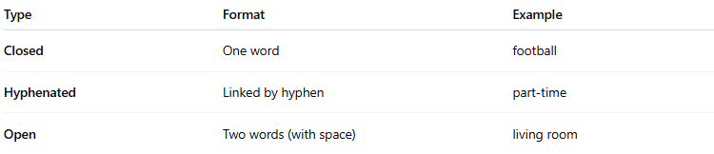
Type | Format | Example
Closed | One word | football
Hyphenated | Linked by hyphen | part-time
Open | Two words (with space) | living room

📌 Summary:
# Source: AI Source: Provided by: [Data Path: Persons Table -> ID Column: 1, Name_En Column: Motasem Essam] -> From: [Chatgpt (GPT-4-turbo)] on [7/25/2025]
- Open compound words are written with spaces but act as one idea.
- Common in everyday language.
- Part of the natural evolution of word combinations in English.

